**LAB: 10**

Q.1 Write a c program illustrating to pass structure within functions.

**Program**

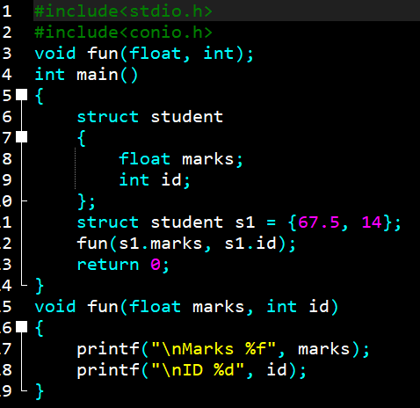

**Output**

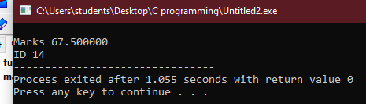

Q.2 Write a c program to create nested structure.

**Program**

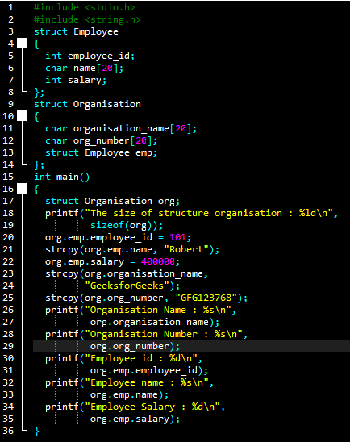

**Output**

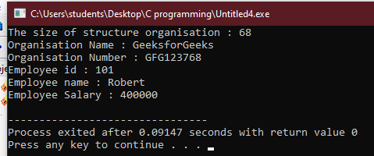

Q.3 Write a simple c program illustrating union.

**Program**

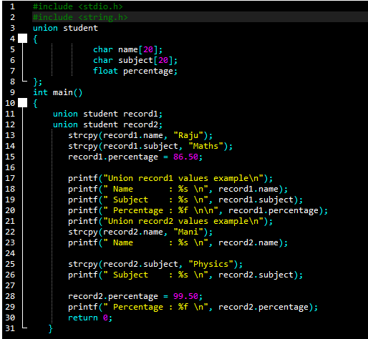

**Output**

